Local Attractions

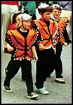
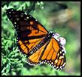
Asilomar http://www.asilomarcenter.com is located in Pacific Grove, California also known as “Butterfly Town USA”. Pacific Grove is known for one of the winter stopovers for the Monarch butterflies. In time with our symposium, you will be arriving with the Monarchs from Mexico. You could walk over to Washington Park to 4 blocks east (1 km) from Asilomar to view the butterflies clustering (native defects?) in the trees. Saturday morning after the conference is the annual Butterfly parade on Lighthouse Avenue. Tour the Pacific Grove website at http://www.pacificgrove.org/

Not only butterflies, but Pacific Grove provides wildlife such as otters and sea lions on the coastline, whale-watching tours, kayaking, biking Sunset Blvd from Asilomar provides a scenic bike path along the beach all the way into downtown Monterey, and beyond. Golf courses are plentiful, Pacific Grove’s public course provides beautiful views of the coast for relatively low fees http://courseguide.golfweb.com/ocdata.cgi/detail?gwid=03907. Not for the sea breeze, visit the restaurants, museums (www.pgmuseum.org) or the wineries. And if Pacific Grove is not enough, you can visit nearby Carmel, Pebble Beach or Monterey.

Pebble Beach – Famous 17 mile drive http://www.pebblebeach.com/

Carmel – More shops than people see, http://www.carmelfun.com/ or http://www.carmel-california.com/ or http://www.carmelbythesea.com/

Monterey – Monterey Bay Aquarium www.monterey.com

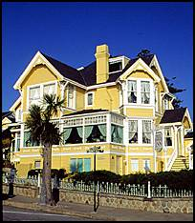
Additional Lodging – If you are registering late, and Asilomar is sold out, early October provides many opportunities to stay at the many Bed and Breakfasts, or hotels in Pacific Grove.

Other hotels that are within short walking distance are,

Andril Fireplace Motel 569 Asilomar Blvd (831) 375-0994

Beachcomber Inn 1996 Sunset Dr (831) 373-4769

Days Inn Pacific Grove 660 Dennett St (831) 373-8777

Deer Haven Inn 740 Crocker Ave (831) 373-1114

Pacific Gardens Inn 701 Asilomar Blvd (831) 646-9414

Rosedale Inn, 775 Asilomar Blvd (831) 655-1000

